QT – install and config in VS

Conteúdo

Introduction 2
QT – Installation on VS 2
Registering the QT version installed with VS 6
QT project templates on VS 7
Creating a new QT project inside the solution 7
IDE overview 12
Resolving problems with Qt projects in VS 13
Changing the General Properties of Qt projects 13
Solving Problem in the qt_defaults.props 13
Solving Problem in the Qt installation on the project 14
APPENDIX A – reference materials 15

Introduction
Qt (pronounced "cute" ) is a widget toolkit for creating graphical user interfaces as well as cross-platform applications that run on various software and hardware platforms such as Linux, Windows, macOS, Android or embedded systems with little or no change in the underlying codebase while still being a native application with native capabilities and speed.

QT – Installation on VS
The QT installation for VS will be accomplish in two steps: Download and install QT platform, Download and install VS QT extension.
Download and install QT platform
Download the QT online installer from the QT Open Source project: https://www.qt.io/download
Execute the installation file: Example: qt-unified-windows-x86-4.1.0-online
- Signin or create a new account on QT
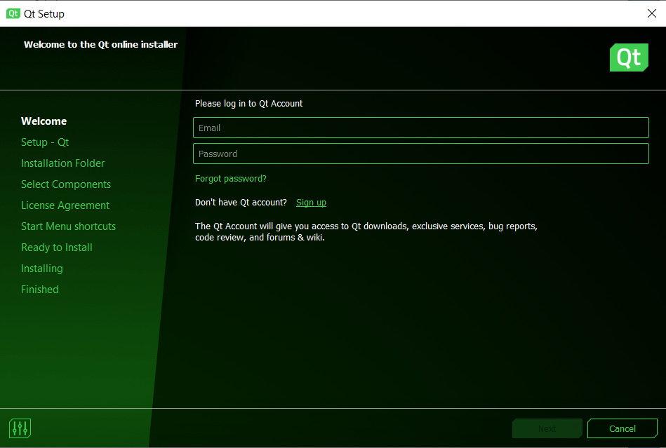
- Accept the license terms and hit next
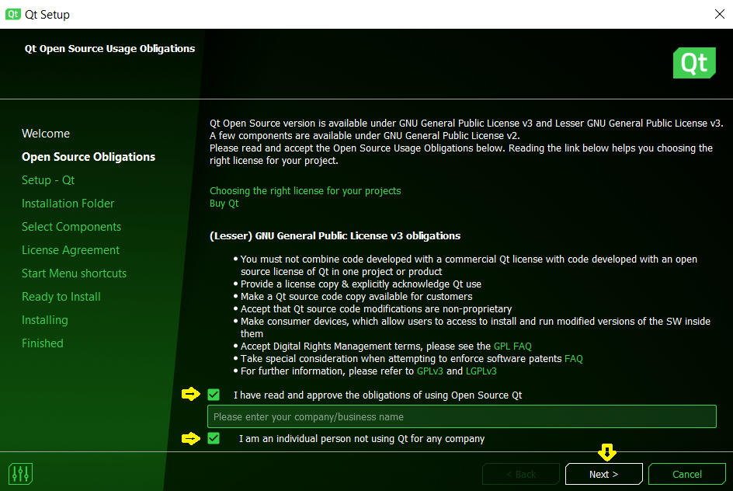
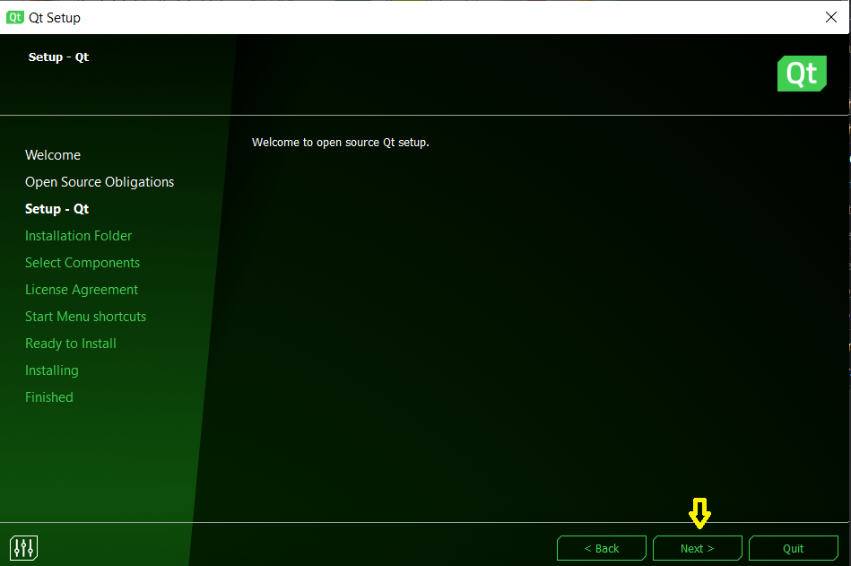
- Accept the tracking usage option and hit next
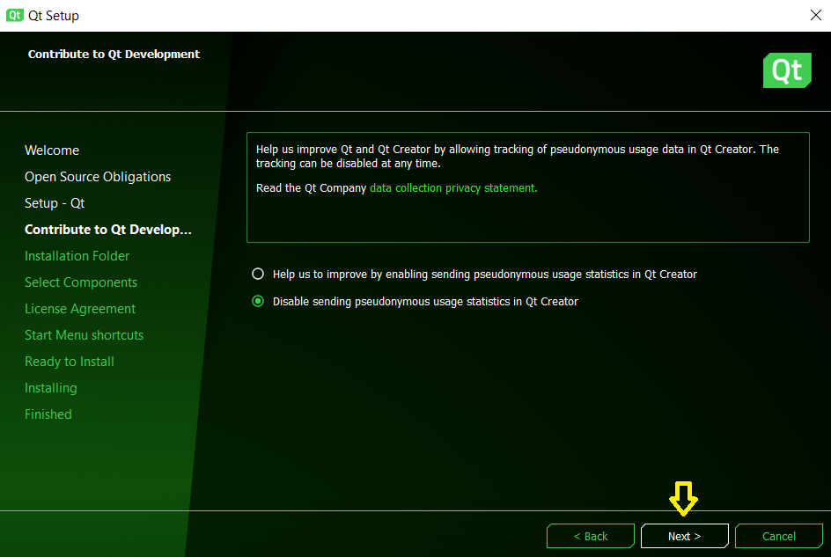
- Define the installation path and the type of installation. Choose Custom Installation
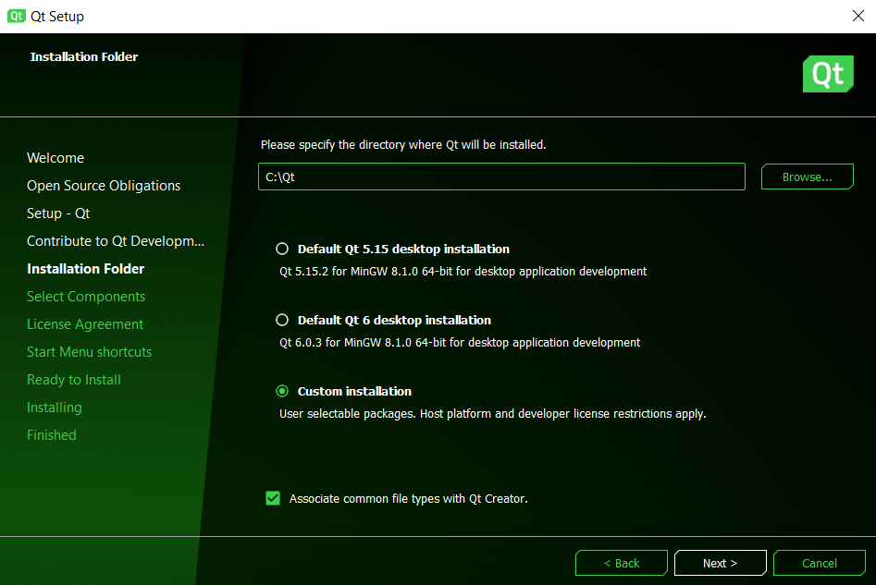

- Select the components to install. We will leave the deault.
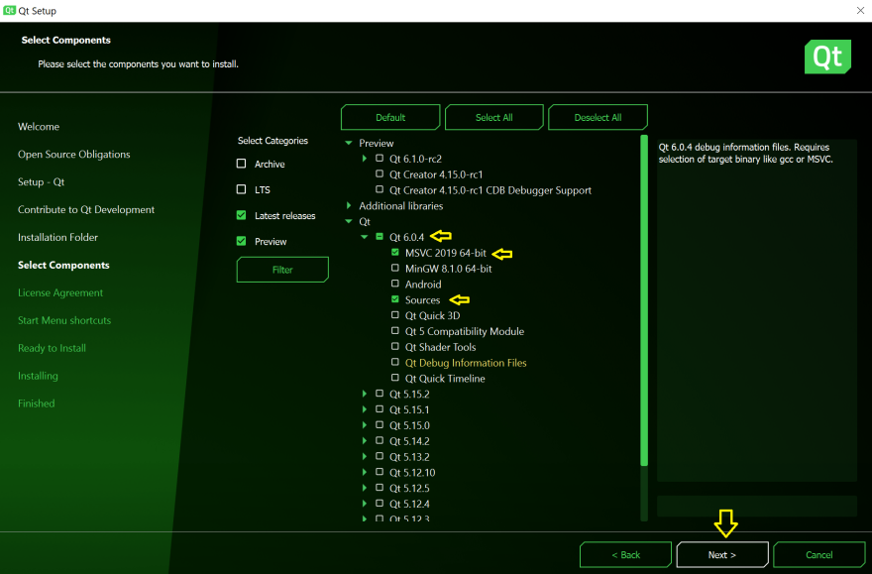
- Accept the license agreements.
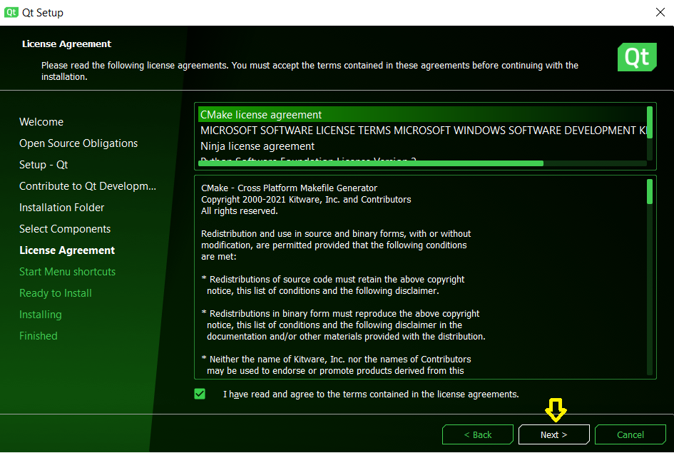
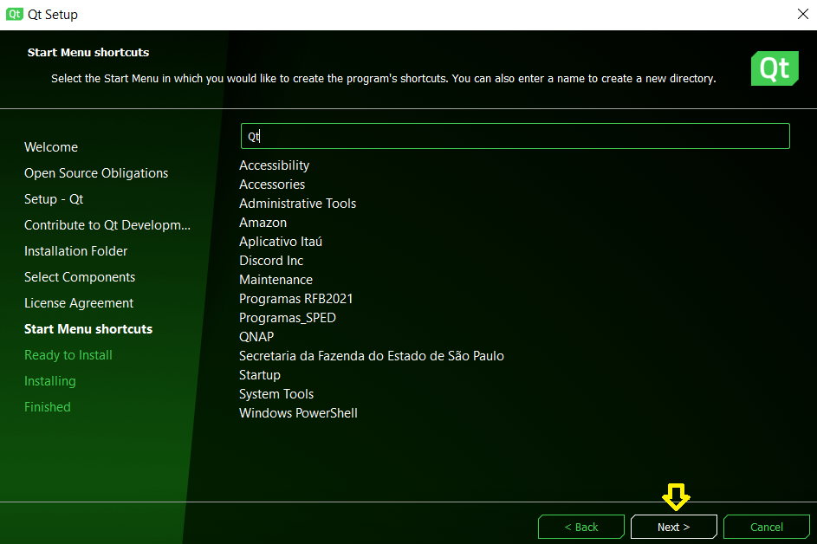
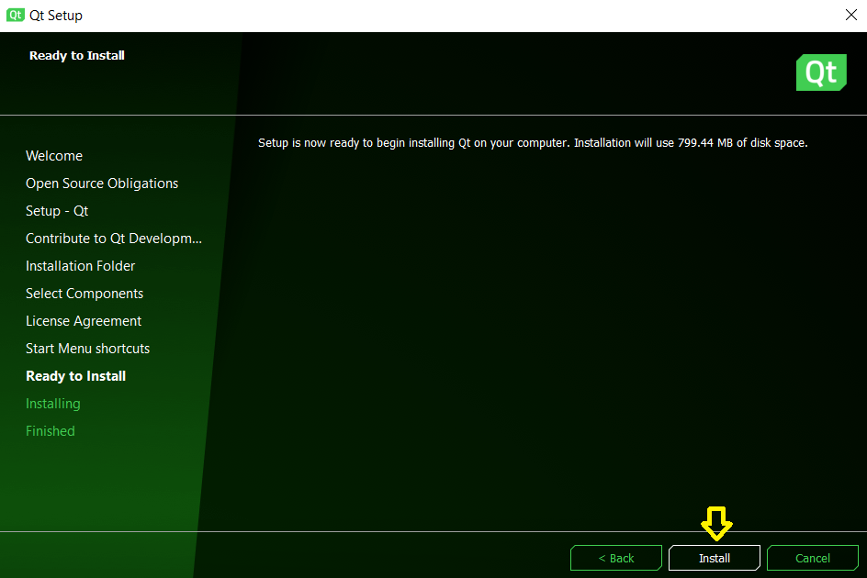
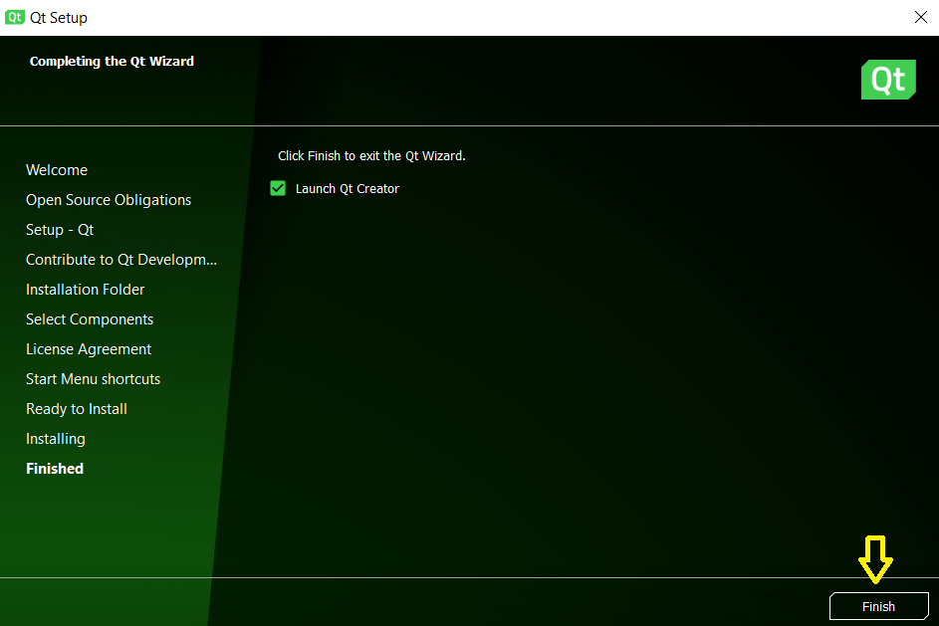
- Finishing the installation the QT Creator will be launched. On this screen you may check different examples for each platform selected.
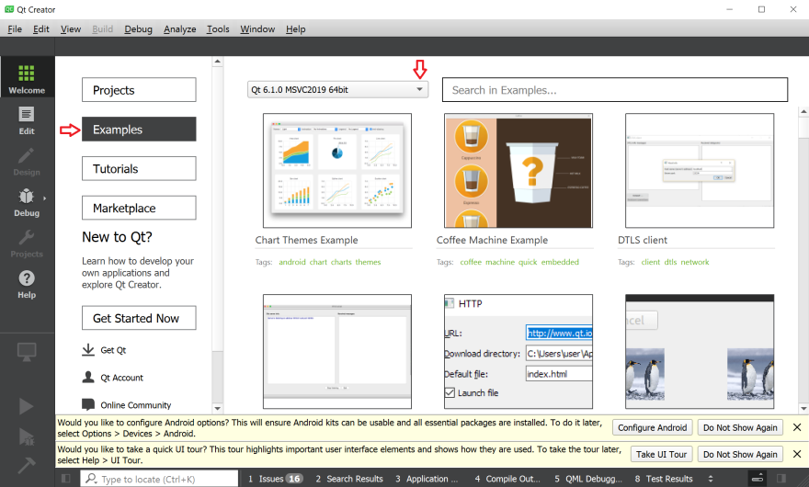

Download and install QT Visual Studio extension
After the successfully QT platform installation, download and install the following VS extension:


Registering the QT version installed with VS
The next step to use QT inside VS, is registering the installed version on the VS.
Select Extensions on the main menu and then Qt VS Tools and then Options
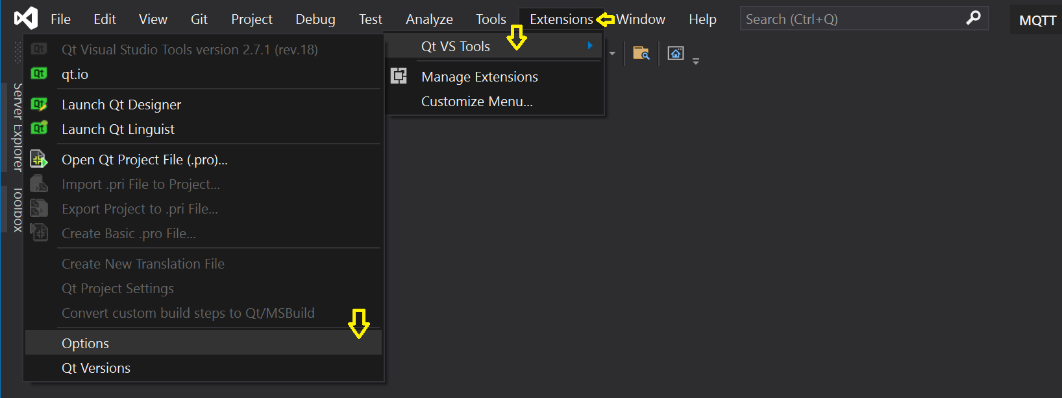
On the next screen you will add the name and the path where QT was installed.
You may register as many QT versions you need on VS.
On the next screen hit <add new QT version> and fill with the following information:
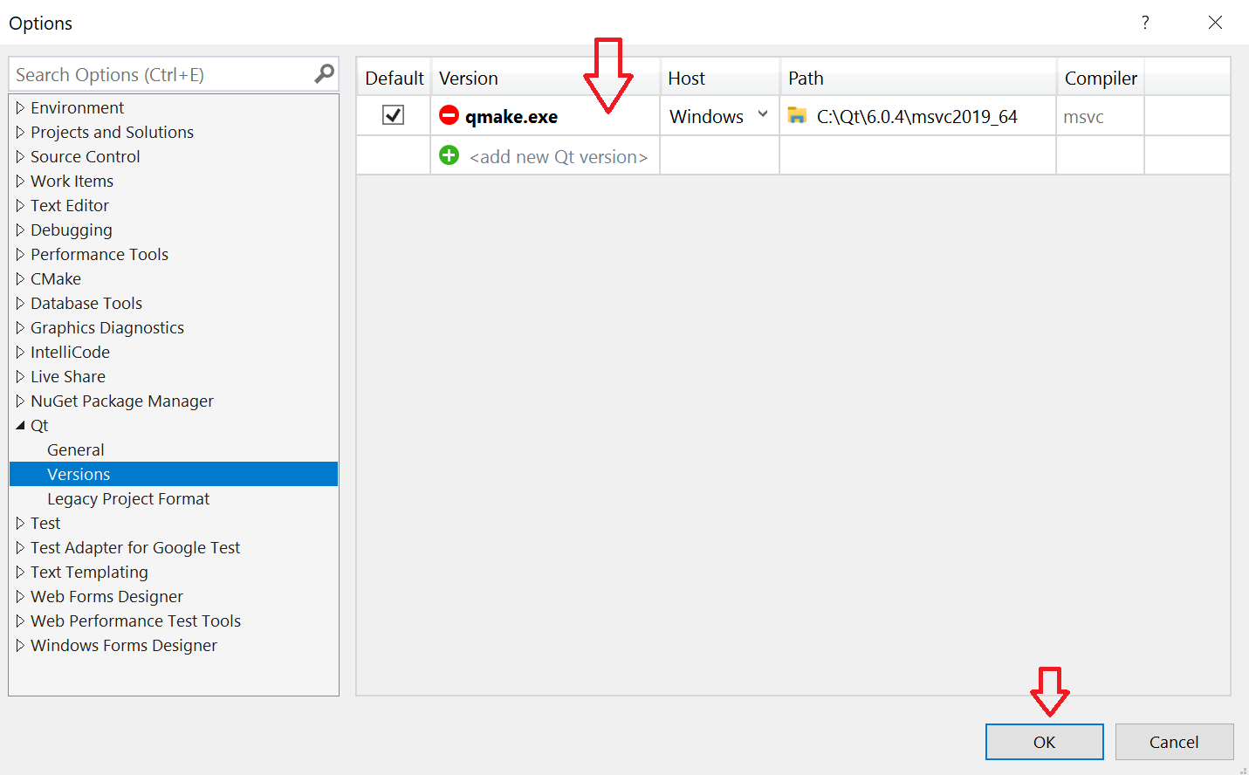
Version: qmake.exe
Host: Windows
Path: C:\Qt2\6.0.3\msvc2019_64\bin\qmake.exe

NOTE: on this interface we may type any name we want on the field Version. This is a mistake of the interface because the name here should be the name of qmake.exe.

NOTE: Here you can add and remove different Qt versions you intend to build on. Its important to note, that if you have both Visual Studio 2017 and Visual Studio 2019 setup with the Qt extensions, they will share the same Qt Options, so removing one from one, will result it being removed from the other.

Resolving problems with Qt projects in VS
After the installation of (Qt plataform and Qt extension) I faced problems during the build of my first Qt project. To solve this, I had to make some manual changes to the VS environment.
The problems seems to be related with the QT Visual Studio Tools extension. I will need to check this on the next available versions.
Two changes was done based on the articles detailed on the appendix A and are detailed on the following steps:

Changing the General Properties of Qt projects
During the first build of my first Qt project, messages on the Output windows described that at least /std:C++17 was needed to Qt. Researching the web I found the article 1 and executed the following process to make the necessary changes on the Qt project:

Right click on the Qt project name and them select Properties
Change the C++ Language Standard to: ISO C++ 17 Standard (/std:c++17)

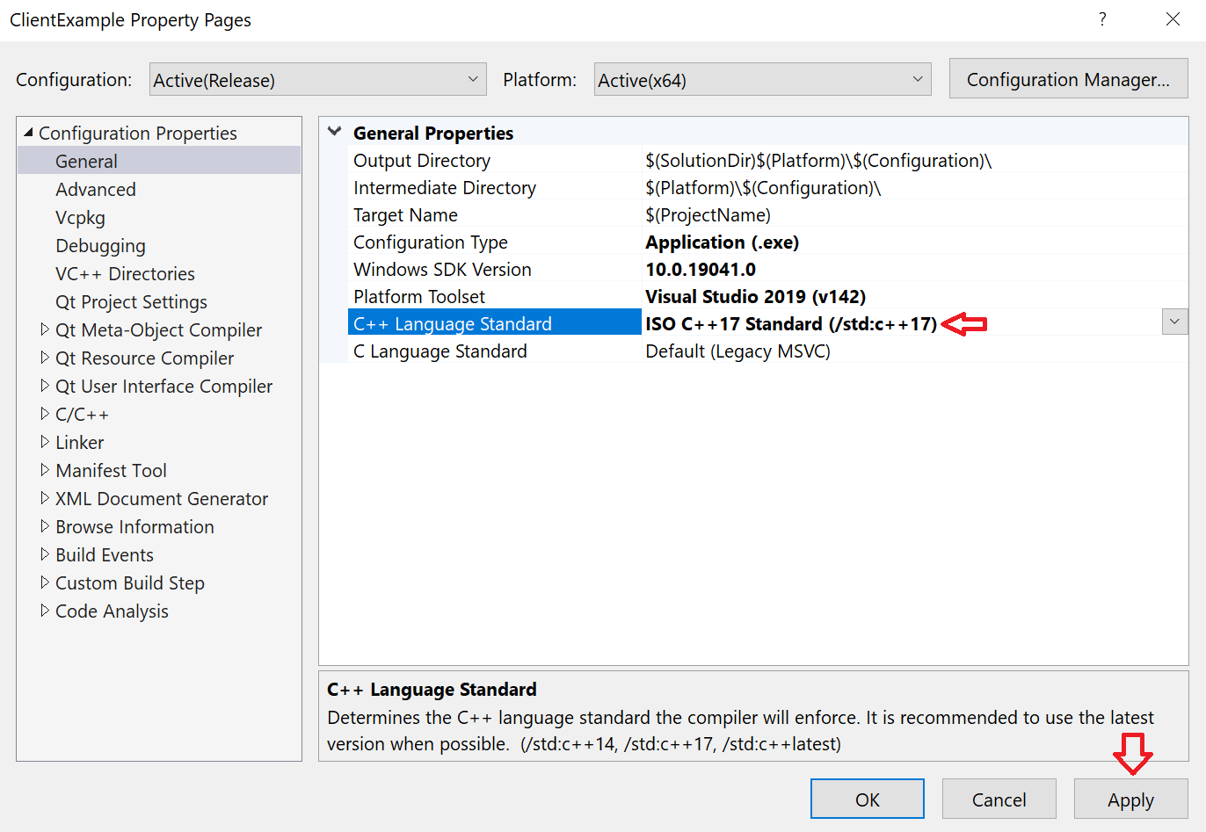
NOTE: this configuration should be done for Debug and Release option selected on the VS main menu.

Solving Problem in the qt_defaults.props
The article 3 describes a Problem in the file qt_defaults.props with $QtBuildConfig when project name isn't "debug" or "release".
The qt_defaults.props is a hidden file installed on the following sub-dir:
C:\Users\decio\appdata\local\QtMsBuild\qt_defaults.props
The article suggests to change the following portion of this file:
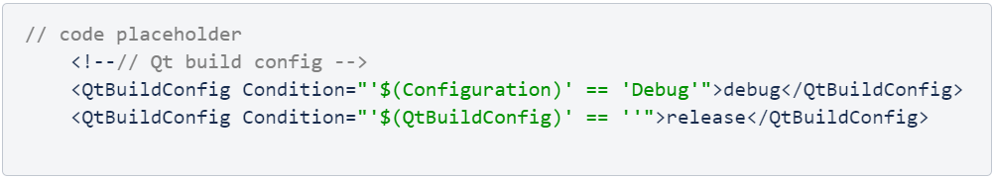

Solving Problem in the Qt installation on the project
The last problem i faced was to change the Qt installation defined to the Qt project. It seems that this problem was raised because I did a mistake during the procedure : “Registering the QT version installed with VS”. On this procedure, the Version is not a free field, it should contains the exact name of the qmake: qmake.exe

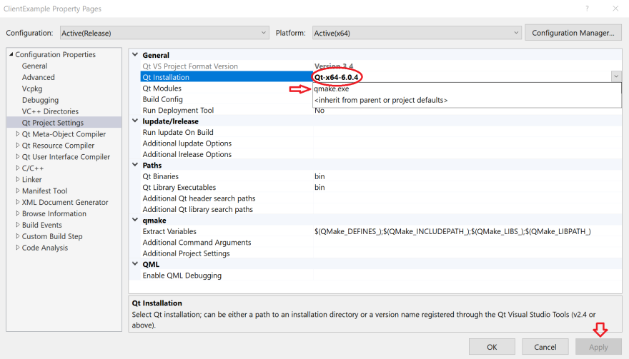

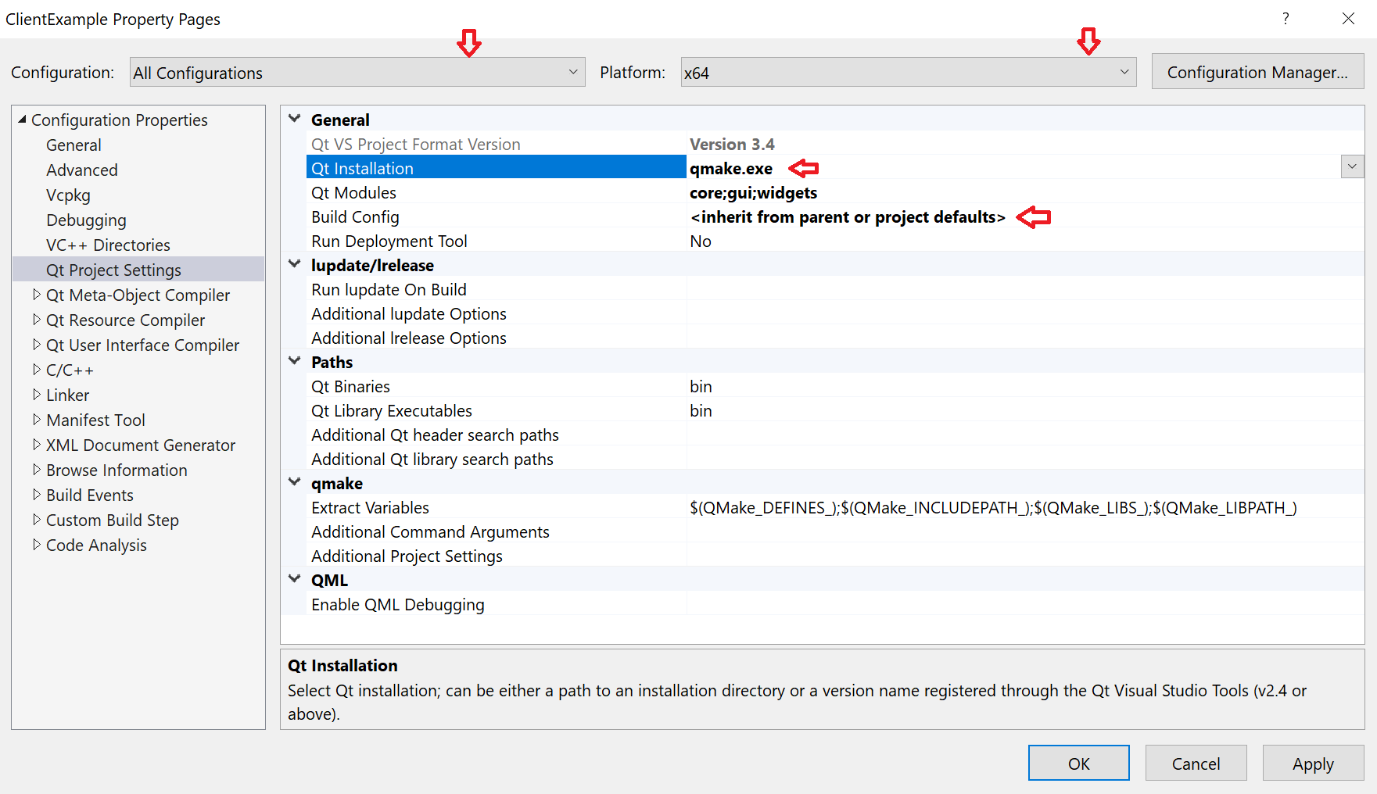

APPENDIX A – reference materials
Article 1:
https://docs.microsoft.com/pt-br/cpp/build/reference/std-specify-language-standard-version?view=msvc-160

Article 2:
https://docs.microsoft.com/pt-br/cpp/build/working-with-project-properties?view=msvc-160

Article 3:
https://bugreports.qt.io/projects/QTVSADDINBUG/issues/QTVSADDINBUG-904?filter=allopenissues

